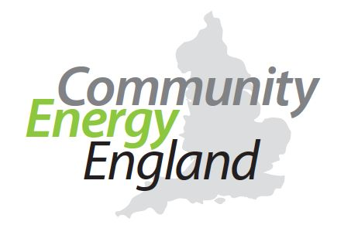

Ask your MP to support Community Energy

Writing to your MP takes no more than 5-10 minutes of your time, but has a real impact in informing MPs about the issues currently impacting the Community Energy sector, as well as letting them know that the people who vote for them care about policies that will help tackle the climate emergency. Just follow these simple steps:

- Find your local MP by typing in your residential postcode here.
- Find your local MP.
- Scroll down the resulting MP webpage until you find your local MP’s email address.
- Copy and paste the letter below, which you can adapt to suit you, into an email. Make sure you add your address and postcode to the email so that the MP realises they are being e-mailed by one of their constituents.
- Write “Please support Community Energy” (or similar) in the subject line.
- Send the email to your MP. Feel free to copy in xxxxx@communityenergy – this way we can chase on your behalf if needed and we can keep tack of which MPs have received this letter
- Please forward us a copy of the reply, thank you.

Dear MP NAME

I am writing to you because I am deeply concerned by the current government policy position that excludes Community Energy schemes from being eligible for Social Investment Tax Relief (SITR).

I am a member of [insert local Community Energy Group name] OR I am a supporter of [insert local Community Energy Group name]. We exist/The group exists to help our local area become more energy efficient; to increase the use of clean, green renewable energy; and to support the transition to a decentralised, smart energy system.

Community energy is all about community innovation, primarily by volunteers. To do this well, we need risk capital and therefore the ability to reward our investors when they provide that to us. Tax reliefs are a key way for community enterprises to give such a reward because we rightly have tight restrictions around what we do with any surplus from selling assets or increasing their value. The reintroduction of tax relief for community energy projects is therefore essential to making sure communities can contribute to making the energy transition happen in a way that leaves no one behind.

Government has removed the Feed in Tariff that schemes could previously benefit from, and there is still no certainty around the proposals for energy companies to buy back surplus energy from community energy groups, known as the Smart Export Guarantee. All at a time when we know we have just 12 years to act to halt the climate crisis, and when we’re collectively trying to encourage UK citizens to adopt more carbon neutral lifestyles.

I would be grateful if you could raise my call for the reinstatement of tax relief for investors in community energy schemes with the relevant Ministers. I look forward to receiving a response. If you would like to join us at [insert local Community Energy Group name] to find out more about Community Energy and our current plans, we would be very pleased to meet with you.

Yours sincerely,
NAME, ADDRESS

