Briefing for members for the Climate Coalition’s Virtual Lobby

Aim
To help members feel confident to advocate to their MP on Community Energy’s behalf - a prompt sheet they can use in the meeting. Please print, cut and paste, annotate - use as is useful to you. Please, if possible, get together with Community Energy (CE) colleagues to do the lobby.

Content
How to set up the lobby
- https://www.theclimatecoalition.org/virtual-lobby to register
- https://www.theclimatecoalition.org/virtual-lobby/resources for resources on writing to your MP to get an appointment with them. SUGGESTED DRAFT BELOW.

SUBJECT LINE: Invitation to meet on 30 June - the Time is Now virtual lobby for climate, nature and people and a healthy, green and fair recovery

Dear [Jo Bloggs MP],

My name is [your name] and I am a constituent. Thank you for your continued hard work representing [Your Constituency], especially during a time such as this. I know your current focus will be supporting those most affected in our area and continuing your Parliamentary work as far as possible.

I would like to invite you to meet me and other constituents as part of a virtual lobby for a healthy, green and fair recovery from coronavirus on 30 June.

I am involved in [details of your project - maybe mention any Covid related activity] I would particularly like your support in putting people and communities - who have so showed their value in recent weeks - at the centre of energy, net-zero and recovery policies. Without the consent, trust and participation of the people none of these will succeed.

The UK is at a turning point. As we build back from the current health crisis, we have the opportunity to tackle climate change and nature’s decline, and rebuild a resilient economy that benefits everyone in society. Or we can lock in pollution for decades to come.

You may remember The Time is Now mass lobby last year when 12,000 people flooded the streets of Westminster to ask for action on the climate and nature emergency. We can’t meet in person this time, so please could you set up an online conferencing link (e.g. Zoom) at a meeting time on 30 June convenient to you, and send it to me.

You may receive similar requests from other constituents. I would be happy to join those people in the same virtual meeting so we can speak to you at the same time, if that is more convenient for you. I know you’re busy, so even 20 minutes of your time would be appreciated.

Please confirm the time of our call as soon as is convenient.

Thank you,

[Your name and postcode - required for them to act on this letter]

Community Energy – Empowering and Repowering
This document is a resource for people and groups who want to lobby their MPs on community energy’s (CE) behalf. As such it provides brief information on what CE is, what it offers, and what it needs from local and national government.
The virtual lobby is an initiative from the Climate Coalition with the aim to place people, the climate and nature at the heart of the Covid 19 recovery. This takes place on the 30th of June 2020 and can be signed up to above and there are resources here.
This document will detail briefly what CE offers and how best national and local policy frameworks can support and make the most of this offer. We hope you can adapt it to use as notes for your virtual lobby of your MP. Please add lots of local colour, examples and references.

What is Community Energy?

CE is your constituents getting together to work on energy and climate change locally, installing community- owned renewable generation, doing education, energy efficiency and fuel poverty work, building community resilience. CE is a form of community wealth building that recycles money and develops skills and networks within and between communities. It helps reduce carbon emissions, lower local pollution and other environmental impacts. Overall, it helps to build more cohesive and democratic communities that are able and committed to doing their bit in mitigating the climate crisis.

[Please use local examples - consider having up-beat people-filled pictures of your project in case you get an opportunity to share your screen]

The Offer:

CE has economic impacts:
- It created £4.6 million of local economic impacts in 2019, including grants and loans (£2m), cost savings for local people and businesses (£1.9m), and community benefits (£720,000)
- Compared with commercial generation modelling suggests that CE retains approximately 12 times the local economic value
- It allows people to invest ethically in local community projects

CE has environmental impacts:
- It has prevented 65,200 tonnes of CO2
- It leads and funds local environmental programmes in schools
- It works on conservation and habitat improvements
- It works on energy efficiency and demand management initiatives

CE has social impacts:
- It offers crucial support for those in fuel poverty
- It builds capacity and resilience in communities through environmental training and workshops
- It raises awareness and buy-in to the need for behavioural changes to mitigate the climate crisis
- It reduces local opposition to renewables through greater local participation and benefit sharing

What CE needs from Central and Local Government

We need government at all levels to understand and appreciate the current value and future potential of CE. With the right support it has the potential to grow exponentially again to between 12 and 20 times its current scale by 2030 according to an independent report by WPI Economics.
The Committee on Climate Change, in its Net Zero Report says that, "It will not be possible to get close to meeting a net-zero target without engaging with people or by pursuing an approach that focuses only on supply-side changes...Some of the difficult decisions that will be required (...) will only be possible if people are engaged in a societal effort to reach net-zero emissions and understand the choices and constraints...There is currently no government strategy to engage the public in the transition to a low-carbon economy. This will need to change.”
Community energy is key to getting the consent and participation of the public and therefore essential to achieving net zero. It should be supported by government for that reason and for the huge social and community benefit it brings - 12-13 times more than commercial installations, according to research commissioned by government in 2014.
The graphic below shows modelling of how CE can spur local economic value under the right conditions. 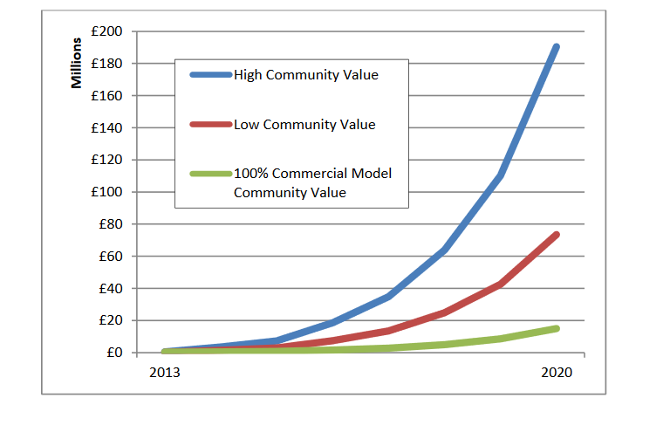

Due to the withdrawal of virtually all support for community energy over the last 5 years the sector is struggling to make a business case to get active. To re-activate this potential powerhouse for the energy transition the government needs to offer some policy and financial support. The government has recognised that even the cheapest form of renewable energy, onshore wind and solar, needs government support and certainty to enable it to help meet our challenging climate change targets. The same applies to community energy.

Some of the changes the CE sector would like to see to keep doing its valuable work and to realise its potential include: Measures marked ** are priorities if you are sharing the meeting and have limited time.

Strategic Measures
- **Place people and communities at the heart of the coming Energy White Paper and Net-Zero and Recovery Plans, for instance by creating a new Community Energy Strategy with input from BEIS, a cross departmental working group and the CE sector
- Government and Ofgem to identify and fund an approach to ‘Local Area Energy Planning’ that allows for a central role for CE groups and simplifies and streamlines processes to reflect the urgency of the climate crisis
- Invest heavily in energy efficiency retrofit and fuel poverty with a central role and funding for community energy.

Specific Policies
- **Ask for a meeting with the Energy Minister, Kwasi Kwarteng, with representatives of the sector to discuss creating a Community Energy Contract for Difference (CfD) pot open to projects below 5MW in the current CfD reforms.
- **Reinstate Social Investment Tax Relief (SITR) for community energy and extend its life to 2023 to spur ethical investment in the sector
- Match the Rural Community Energy Fund with an Urban Community Energy Fund (most emissions come from cities), and extend the Renewable Heat Incentive (RHI) beyond 2021 or improve the RHI

Changes to Planning and Regulation
- Rewrite Ofgem’s mandate to include decarbonisation and increasing social benefit from the energy transition.
- Reform the planning system to facilitate achieving Net-Zero as quickly as possible (not just sustainable development) and with CE valued in this system for its social and environmental added value. [[A White Paper to bring the planning system into the 21st century is promised in the Autumn]]
- Fully remove the planning blocks to onshore wind in England and encourage and incentivise a strong element of community participation and ownership (as this is proven to reduce local opposition)
- A reform of the Social Value Act 2012, to really include value for money, not lowest cost. This would involve properly weighing the many social and environmental benefits of CE in planning and procurement decisions. For instance, building homes that are not passive house standard is not value for money.

And finally
Please
- visit our project when lockdown is over,
- sign Community Energy England’s Open Letter to the Prime Minister bit.ly/ceepmletter,
- read Community Energy England’s very short Parliamentary Briefing at bit.ly/CEEBriefing which reinforces our asks.
- and become our community energy champion in parliament.

Net Zero - The UK's contribution to stopping global warming
Community Renewable Electricity Generation: Potential Sector Growth to 2020
WPI Report - The Future of Community Energy
This includes the removal of ROCs, the Feed-in Tariff, Export Tariff, the Urban Community Energy Fund and Tax Relief, punitive business rates on root-top solar, planning constraints on on-shore wind and increasing VAT on solar panels, batteries and ‘energy saving measures’ from 5% to 20%.
CEE State of the Sector 2020 Report
Community Renewable Electricity Generation: Potential Sector Growth to 2020
CEE State of the Sector 2020 Report
http://www.energisesussexcoast.co.uk/services/energy-saving/
Procurement Policy Note – The Public Services (Social Value) Act 2012 – advice for commissioners and procurers

