CEE RESP Methodology Consultation Response
January 2026

- Do you agree that in Scotland and Wales the strategic plans outlined in this methodology should be known as the Scotland RESP and Wales RESP respectively?

Engagement and Local Actor Support

- Do you agree with our approach to engagement as we develop the RESPs?

We welcome the ‘strategic, whole energy and bottom-up approach’ set out in the consultation. The success of the RESPs will largely depend on how well communities are able to direct their own energy futures through these processes so plans for a ‘place-based, transparent and collaborative, and fair’ approach in which ‘local people are set to play a key role in helping shape future energy systems to enable delivery of local ambitions and priorities’ are critical. We also strongly welcome plans for ‘additional support for local authorities and local energy representatives’ taking part in RESPs and look forward to seeing more detail on how this will work in practice. We support the proposed three year cycle for developing RESPs.

- Do you agree with the approach we have outlined on local actor support, and how we have phased the delivery?

Local actor support is one of the most crucial elements in ensuring the RESP is successful in developing genuinely bottom-up, democratic pathways to net zero. We welcome the commitments set out to include community energy organisations in the RESP process as key local actors. We believe, as is set out in the consultation, that community energy must be empowered to fully participate in Strategic Boards, relevant working groups and the GB Energy Steering Group.

Engaging meaningfully with RESPs will be likely to require a significant time commitment from highly experienced energy professionals. The vast majority of the community energy sector operates with small staff teams. Therefore, community energy organisations are likely to find allocating the necessary time and resources to RESP boards and groups more challenging than other sectors. We set out some ways in which these difficulties can be mitigated within the boards and groups in the following answers. But more broadly, engagement with the community energy sector must go beyond these formalised structures.

Proactive outreach from RESP teams to local and regional energy networks, inviting genuine opportunities to feed into the processes would ensure RESPs better reflect local needs, priorities and opportunities. It could also foster positive collaborations between the community energy sector and other actors involved in the development of RESPs, such as local authorities. Equally, it would reduce the reliance on a small number of individuals formally representing the sector, who should not be expected to have a deep knowledge of the entire community energy sector’s priorities within a given region.

Organisations and networks such as the Energy Learning Network and the Regional Net Zero Hubs could play a useful role in signposting RESP teams to local and regional networks. For example, the South West Net Zero Hub is supporting the growth of support networks in Solent, Wessex, Dorset, and Cornwall to complement the existing one in Devon. In some regions, there are already established community energy umbrella organisations, such as Community Energy London, which will be crucial in helping to identify opportunities for local input.

Governance

- Do you agree that Local authorities should be able to decide whether to send a political representative or officer to the Strategic Board?

Yes. We would be happy to supply NESO with a list of local authorities that are proactive and ahead of the curve in developing energy transition projects in collaboration with their communities.

- Do you agree with our proposed voting structure for Strategic Boards? If you think we should change it, please provide your reasoning.

The proposed board structure gives 10% voting rights to ‘cross-sector actors’, up to four of which may sit on boards of 16 people. Cross-sector actors, according to the proposals, could include representatives from industry, transport, consumer or community energy.

Membership of community energy organisations gives local people a stake in their local energy system and a chance to have a say in the design and ownership of the renewable energy appearing in our urban and rural landscapes. On a Strategic Board, a single community energy representative, as part of a group of four cross-sector actors, would command a 2.5% voting right on a RESP. This is too small a stake, particularly in regions where community energy has a significant presence and membership (although it should be noted that community energy is a key future delivery partner for the whole UK energy system). We recommend that the cross-sector actors’ cumulative voting rights are extended to 20% and that the community energy sector is offered at least two seats on any given Strategic Board.

Given that there will be a small number of total community energy representatives on any given Strategic Board however they are constituted, it will be crucial that RESP teams’ outreach to local energy networks including community energy organisations enables them to genuinely input into the Plans.

- Do you feel any changes should be made to the proposed terms of reference?
- Do you agree with our proposals for appointing members of the strategic boards?

We would be interested in seeing more detail on what the targeted application process for cross-sector actors interested in sitting on Strategic Boards will involve. For example, will specific organisations or people be directly invited to apply? As the sector’s representative body, Community Energy England should have a role in publicising opportunities for community energy practitioners to sit on Strategic Boards and inform who should represent the sector. We would then have a stake in ensuring they are properly supported with input from the sector in their area.

Membership of a Strategic Board is likely to involve a significant time and resource commitment for a community energy practitioner or organisation. We understand that NESO does not intend to offer remuneration for membership of Strategic Boards generally. However, we believe exceptions should be made for not-for-profit organisations with relatively low turnovers compared to other organisations represented on Strategic Boards. This is particularly important for community energy practitioners who may find themselves unable to participate without remuneration.

Community energy has a crucial role in ensuring that local and regional communities have direct channels into the Strategic Boards that go beyond local authority representation. Their voice will give a greater democratic mandate to the development of the Plans and so NESO must enable them to fully participate in the RESP processes with the necessary remuneration for their time.

- Do you agree with our proposed design for working groups?

The points we raise in our answer to question 7 on the need for remuneration for representatives of not-for-profit organisations with smaller turnovers relative to other organisations involved applies equally to working groups.

As mentioned in the consultation document, community energy practitioners will be particularly important on the Consumer and Commercial Demand Working Group and the Generation Working Group at each regional level. Many practitioners have practical experience of working on projects relating to heat, flexibility and fuel poverty and will have a good knowledge of local and regional circumstances and needs relating to these areas.

Given the vital importance of collaboration between Local Authorities and community energy organisations to achieve the ambition targets set by the government for ‘local and community energy’, it will be important that there are representatives on the Local Government Working Group who have strong experience of the benefit of working with community energy and can advocate for that. CEE can supply recommendations of authorities that are very engaged with their community energy partners.

We would be interested in hearing more about NESO’s approach to recruiting members to the national level Technical Working Group, with its remit to consider cross-cutting technical issues and input to Consistent Planning Assumptions. It may be appropriate for one or more community energy expert practitioners to be invited to attend this group. Community energy is an innovative sector that undertakes projects that use multiple energy technologies while delivering benefit to local communities. It can therefore offer a valuable and unique perspective when considering certain cross-cutting technical issues. See our response to q 13 on Whole Energy for the kind of thinking that community energy experts can bring to that Technical Working Group).

For example, the community energy sector has experience delivering flagship projects involving demand flexibility (through smart local energy systems), which may help to shape the assumptions set out by the Technical Working Group. CEE also hosts a low carbon heat working group, which contains extensive expertise in delivering projects across different renewable heat technologies. Even if community energy is not represented full time on the Technical Working Group, it may be useful for experts to be invited to attend and feed into meetings on specific topics.

Community energy representatives on the GB Energy Steering Group may be best placed to advise on how community energy should participate in the Technical Working Group.

- Do you agree with the proposed representation for the GB Steering Committee? If not, are there other participants you feel we should consider?

The consultation mentions that members of the GB Steering Committee may be drawn from the community energy sector. While this is welcome, community energy representation in the group cannot be seen as optional. Growing community energy is one of GB Energy’s key strategic objectives and the Energy Secretary has stated that GB Energy will oversee the biggest expansion of the sector in British history.

Community energy is a key player in the UK’s energy future and will contribute knowledge and experience in delivering projects with and for local communities that will be critical for the success of the RESPs. Community energy already has more generation than Octopus and is set to scale. It also operates at the crucial local level that must anchor the energy transformation. It is ‘smart’ in that it can engage with the key energy decision-makers, citizens, and mobilise them to become proactive participants and agents for change in the transformation.

- Do you agree that we should not be making major changes to the RESP methodology within cycle? If not, please can you give examples of circumstances where you think this may be necessary?

The RESP components

- Do you agree with the approach for the Nations and Regions Contexts? Please provide your reasoning.
- How do you envisage using the Nations and Regions Contexts and what would make the output work best for your needs?
- Do you agree with the scope of ‘Whole Energy’ for RESP outputs?
We wholeheartedly support the Whole Energy scope, alongside the place-based, vision-led and proactive approach.

This response is informed by our members who are place-based visionary, proactive practitioners, often system-thinkers very grounded in the real world and focused on ‘putting people at the heart of the energy transformation’, delivering benefit, agency, control and ownership to local people. I hope the responses to this and question 26 (NPA on GDNs) show why community energy should be actively involved in shaping the RESPs.

The Consistent Planning Assumptions appear to be more about harmonising demand assumptions around growth of demand of electricity and gas to better predict and organise the transition from gas to electricity. It doesn’t seem to challenge the status quo assumptions of a system that supplies energy to consumers. Community energy is key to the energy transformation because it can mobilise the genius, passion, expertise and money of the community to come up with replicable, locally appropriate Smart Local Energy Systems that deliver benefit to local people and (if properly integrated) to the system, reducing the need for supply side reinforcements.

We haven’t yet seen strong evidence of a clear process to review the whole UK energy system to identify what is missing. One such element is a transformation to a ‘bottom-up’, ‘Smart Local Energy System’, where as much as possible is generated, supplied, balanced, stored, traded, and shared locally. These would ensure the transmission system only has to grow to fulfil ‘top up needs’ rather than to double or triple in size to supply all local needs. This local level is what to date has been virtually invisible to the system (and regulation). This needs urgently to change and requires a radical change to system architecture, so that local data is collected, processed and transmitted (in a standardised, interoperable way) to enable the customer, the local projects, the distribution network and the transmission network to respond seamlessly and flexibly to maximise efficiency in our energy system.

We recommend a common model and language to analyse the system and where particular interventions within it would sit and how the interactions would need to flow. We recommend the adoption of the Smart Grid Architecture Model, used by the Energy Systems Catapult and the ENA until recently. SGAM is a reference framework for systematically describing smart grid use cases, architectures, and interoperability requirements. Its purpose is to provide a common architectural language for stakeholders to describe a use case's location in the power system, understand required functions, data models, protocols, and components, and assess interoperability gaps.

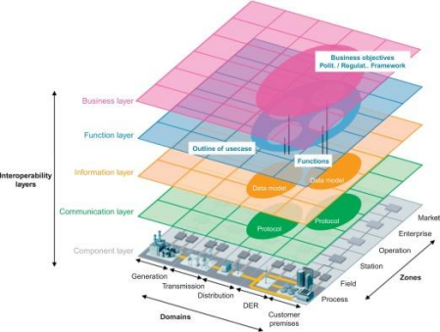
SGAM is a three-dimensional cube combining:
- Domains (system scope): Describes where the function or use case applies in the electrical energy conversion chain. These domains are Generation, Transmission, Distribution, Distributed Energy Resources (DER), and Customer Premises.
- Zones (management and control hierarchy): Describes levels of control and management. These include Process, Field, Station, Operation, Enterprise, and Market.
- Interoperability Layers (what kind of capability): Describes the type of capability or artefact involved, from physical assets to business intent. The layers are:
  - Component Layer: Physical components (e.g., power system equipment, IT hardware).
  - Communication Layer: How information is exchanged (e.g., protocols, network technologies).
  - Information Layer: Shared meaning, including data models and semantics; turns raw data into system intelligence.
  - Function Layer: Logical functions and services that realize a use case.
  - Business Layer: Business objectives, policies, and regulatory frameworks.
A critical gap in today's system is the missing "middle". This is the absence of coherent Information nodes, specifically Community Energy Management Systems (CEMS), paired with a local Function layer, or Smart Local Energy Systems (SLES). This lack of local coordination can lead to issues like uncoordinated flexibility, unseen local constraints, and reinforcement instead of optimization, particularly with the rapid rollout of assets like EVs and heat pumps. With this Smart Local Energy System coordination and optimisation built into the system the real value of local generation, balancing, flex can be realised (and rewarded) to benefit the system and local people who will become much more active participants in the transformation of the energy system - without which, as the Climate Change Committee has frequently commented, ‘we will not achieve net zero’.
The Consistent Planning Assumptions seem to seek to recognise and reconcile complexity in the current system and the established electrification of the energy system without necessarily revealing where the system needs to radically change in order to deliver the best possible, most efficient, energy system whilst also delivering societal benefits, increased participation, and fairness.
It is not just local actors who need support and education in how the energy system works. It needs to be an ongoing process of ‘self-examination’ and fresh thinking about the energy transformation among all players in the system.
Data: (Information)
One of our partners, Stefan Haselwimmer (who developed https://votewind.org/ in collaboration with CEE) comments as follows:
(i) Embrace an open data approach so community energy businesses can easily replicate the RESP methodology.
The datasets used by RESP need to be openly available on an open data portal. The methodology could also be made openly available too.
For an example way of how to do this, see https://data.openwind.energy and https://github.com/open-wind/openwindenergy
(ii) Aim to agree a single common set of asset location GIS datasets so communities are using the same methodology as both RESP and local and national government
Again, https://openwind.energy shows how this could work.
(iii) Develop governance structures that proactively engage community-focused organisations in the RESP methodology
It is not merely sufficient to develop datasets, data portals and data tools. A strong and inclusive governance framework is crucial to ensure that all stakeholders can triage data requests, data standards, etc. Particularly frustrating in this regard is the lack of standardisation across DNOs with regard to substation capacity - this could be easily solved through inclusive governance around open data.
Stefan has kindly offered to represent CEE as an open data advocate in the development of the RESP process.

- How do you envisage using the RESP Pathways and how can we communicate Pathways to support you to use them effectively?
- Do you agree with the approach for the RESP Pathways? If not, please provide your reasoning.

NESO states that electricity supply modelling will be based on projections of future electricity supply by considering stakeholder input, the Nations and Regions Contexts, SSEP and Clean Power 2030 pathways, recent growth trends from the Embedded Capacity Registers, LAEPs and LHEES (where available), the connections queue, historical trends and other data sources.

When modelling pathways for electricity supply, RESPs should also take into account the government’s plan to oversee the biggest ever expansion in community energy in British history. The opportunity community energy offers will not be captured within models and projections unless the vast growth potential of community energy is understood. This can be reflected in models using international comparisons and government aims, plans and ambitions (such as the Local Power Plan, which is expected to be published soon).

Due to the relatively small size of the UK’s community energy sector compared to other international examples, there is a relative lack of data on the sector (the State of the Sector Reports deliver a good overview of community energy in the UK but its data and findings are not exhaustive for the purposes of developing RESPs). This must be taken into account when developing models.

Illustrative examples and case studies could help inform projections; for example, the exponential growth in the UK community energy sector demonstrated between 2014 and 2017 or Community Energy London’s ambition to deliver 1,000 projects by 2030 (equivalent to the entire UK target).

- Do you agree with our prioritisation approach and criteria set out to evaluate the validity of the Consistent Planning Assumptions values? Please provide your reasoning.
- Do you agree with our approach for the Consistent Planning Assumptions? Please provide your reasoning?
- Do you agree with our proposed approach for the Spatial Context? Please provide your reasoning.
- Our preferred approach is to move the RESP delivery dates back to enable option 2. Do you support this approach and are there any other wider factors we should consider?
- How do you envisage using the Spatial Context and how can we communicate these outputs to support you to use it effectively?
- Do you have any observations or suggestions on our proposed approach to managing RESP data?
- Do you agree with our description of the three types of complexity and the examples indicated? What additional considerations should we take to categorise complex strategic energy needs? Please provide your reasoning.
- What further considerations should we take as we develop the approach for specifying and categorising Strategic Investment Needs to ensure consistent regulatory treatment of network investments? Please provide your reasoning.

Supporting Functions and Considerations

- What examples of whole system optimisation opportunities are you are aware of and what considerations should we take to identify, prioritise and develop these collaboratively with you?
- Do you support the selection of Option 2 as delivering best value in assuring alignment? If not, please provide your reasoning.
- What further considerations should we take as we develop the approach to Network Planning Assurance for gas distribution networks? Please provide your reasoning
Over years since electrification was identified as a key way to decarbonise the energy system we have witnessed stakeholders in the gas system lobby for its continued role in order to extract long term value out of the gas network assets. They have proposed multiple ways of decarbonising the gas system from biogas to hydrogen, most of which cannot or should not be rolled out at scale. Ongoing uncertainty over the role of gas delays investment in real low carbon solutions (such as heat pumps) that are already becoming scalable solutions and that, with proper targets and support and investment at scale, would speed down the cost curve.

It is regrettable that the government has not managed to set a clear pathway to phasing out gas or make clear that it will follow Climate Change Committee and NISTA advice and rule out hydrogen as appropriate for home heating. Hydrogen is dangerously explosive, mostly to date produced from fossil fuels, requires expensive adaptation of the gas network to distribute and, being a very small molecule, tends to leak. These factors make it wholly inappropriate for widespread residential use. There is also a strong independent evidence base showing that hydrogen for home heating is not viable at scale. A recent meta-review of 54 studies finds no support for hydrogen heating compared to electrification and heat networks (e.g. https://www.sciencedirect.com/science/article/pii/S2949790623000101).

It has many higher priority uses than home heating such as industrial high heat uses, or as an energy store paired with low-carbon, renewable generation to increase efficiency and reduce constraint/curtailment costs to the energy system. This can also be done at a local level to support local grid balancing/flexibility, further reducing the need for transmission reinforcement. (see Smart Local Energy Systems response to q 13).

Gas (methane and biomethane) when burned releases CO2. When it leaks it is a greenhouse gas with between 80-100 times the global warming potential of CO2 in any time frame that matters. Biomethane is often higher carbon than the natural gas it replaces (unless it is produced exclusively from waste without agricultural inputs such as maize - commonly used in Europe)

Hydrogen is an indirect greenhouse gas, amplifying the effect of methane. Hydrogen emissions over the last decade have contributed as much global heating impact as France.

Injection of biomethane or hydrogen (even if produced in a genuinely low carbon way) is a distraction displacing a small percentage of the fossil gas. It is a distraction designed to slow down the transition to electricity to drive our energy system.

No amount of lobbying of the NESO RESP process must allow ongoing investment developing the gas network on any pretext. Modern housing developments should not be connected to the gas grid and should be built to a standard to require very little or no electricity for their heat load.

There should be an active gas retirement programme with clear mandates and phase-out targets.
Research shows that the most effective policies for accelerating clean technology transitions are those with clear mandates and phase-outs (see Figure 4 in A Positive Tipping Cascade in Power, Transport and Heating: https://global-tipping-points.org/wp-content/uploads/2024/09/A-positive-tipping-cascade-in-power-transport-and-heating_GTP-230924.pdf) :
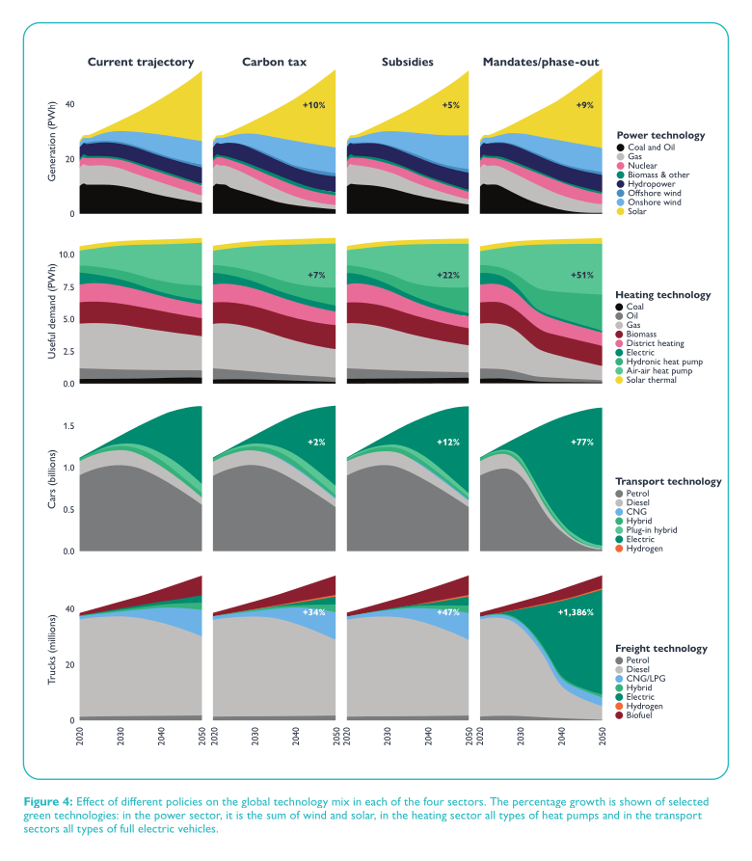
This is the kind of approach already being taken elsewhere. For example, Denmark has adopted a managed phase-out of fossil gas for household heating, including statutory heat planning and explicit regulatory frameworks for gas grid disconnection and decommissioning (see Regulatory Assistance Project: https://www.raponline.org/knowledge-center/nationalisation-wind-down-regulation-of-disconnections-decommissioing-gas-distribution-grid-denmark/).
We understand that the UK is much more gas dependent for heating, while Denmark, due to forward-looking system thinking after the oil crisis in the 70s has moved much more onto renewable energy and heat-networks (albeit that some of those are biomass dependent). In the UK areas must be identified and support given to adopt alternatives at speed, to retire the gas distribution system. This will reduce the heavy maintenance costs which could be spent on the transition. (Ofgem has just authorised £17.8bn to maintain the gas networks).

RESP should also explore repurposing the gas network (see http://heet.org Gas to Geo project in the US where communities are working with the gas distributor to explore using the pipes to deliver ambient temperature ground source water to heat-pump units in buildings for heating and hot water.)
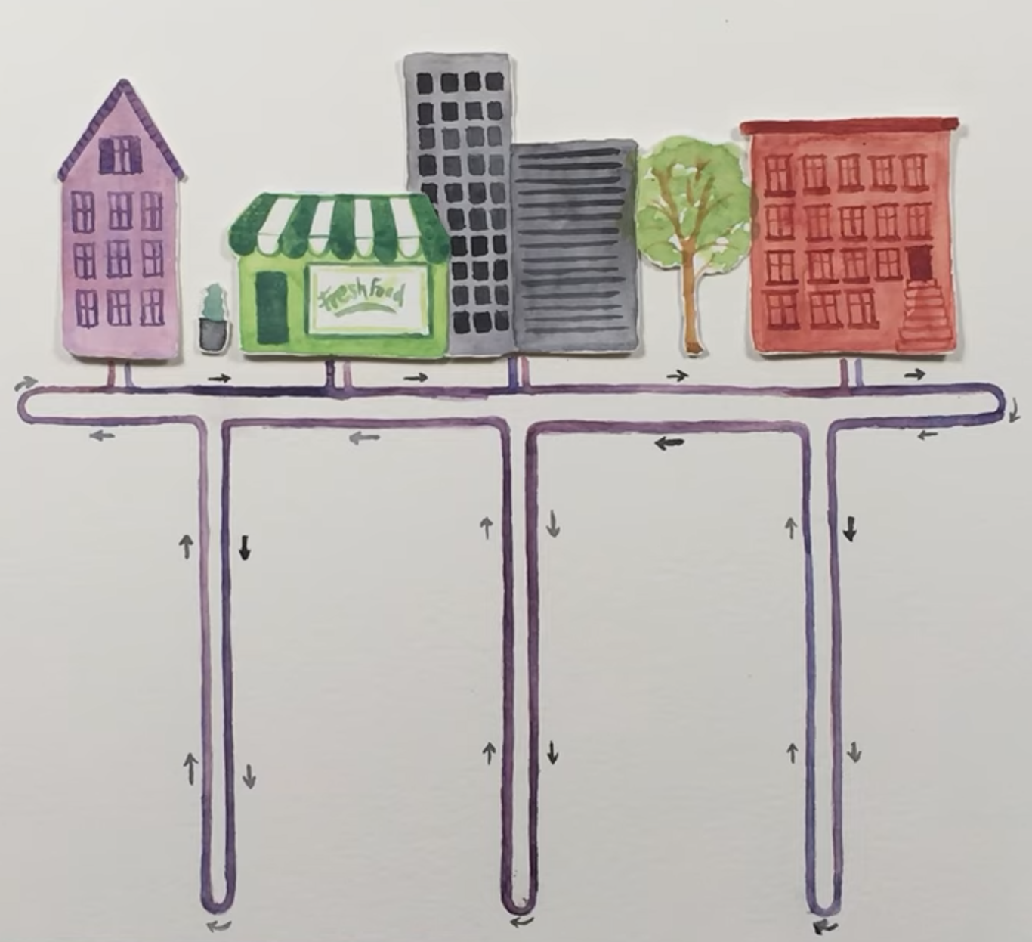

- Do you agree with our approach to societal considerations? What additional considerations should we make on PSED as we develop the RESPs? Please provide your reasoning.

It is crucial that the positive societal impacts of community energy are captured within NESO’s societal considerations, through the Pathways and areas of SI Need. Models must reflect the vastly superior community benefit delivered by community energy projects compared to privately funded projects (and government projects). RESPs will systematically undervalue the benefits, significance and potential of community energy if this is not captured in models and strategic thinking throughout the process of developing RESPs. See response to Q15 for more details.

- Do you agree with our proposed environmental approach? Please provide your reasoning if you think we should be doing this differently.
- Do you have any observations or suggestions on our proposed approach to managing RESP data?
- How frequently do you believe data refreshes should occur to ensure the RESP remains accurate and useful? What criteria should trigger a data refresh? Please provide your reasoning.
- Will commercial sensitivities discourage you or other stakeholders from contributing to the in-development register? What measures could help build confidence in sharing information?
- Overall, do you agree with the approaches proposed across the RESP methodology? Are there any elements of the methodology that you would like to see in more detail?

Signed by
Emma Bridge, Chief Executive, Community Energy England
Email: emma.bridge@communityenergyengland.org Tel: 0114 312 2248

Written by and for further contact:
Duncan Law, Head of Policy and Advocacy, Community Energy England
Email: d.law@communityenergyengland.org
Josh Barnes, Policy and Advocacy Officer, Community Energy England
Email: j.barnes@communityenergyengland.org

Further information

Community Energy England (CEE) was established in 2014 to provide a voice for the community energy sector, primarily in England. Membership totals over 330 organisations. The majority of the members are community energy organisations, but membership extends across a wide range of organisations that work with and support the community energy sector.
www.communityenergyengland.org

